**Machining and Assembly Tips**

**Using a sine vise to drill holes in the Gas Director:**

1. Secure Gas Director blank in hex type collet holder.

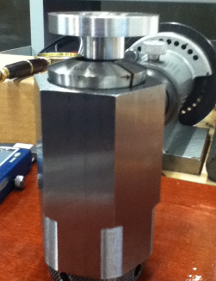

1. Align the edge of the collet holder with the edge of the vise to preserve center while part is indexed.

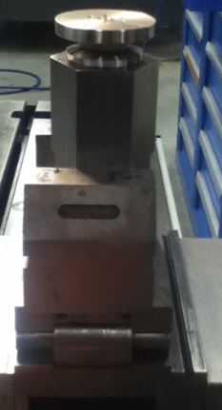

1. Center the part in relation with the quill and set the X & Y axis to zero, then mark center on the part.
2. Set vise for desired angle.

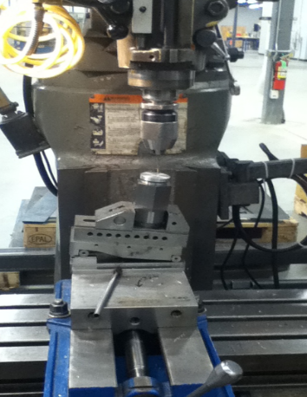

1. Using a fine pointer, move X axis until pointer aligns with center mark on part. Note X axis reading on DRO. Find the sum of the DRO value for X and the bolt circle radius for the holes you are drilling, then move the X axis to this value on the DRO.
2. Center drill, then drill the hole to size.

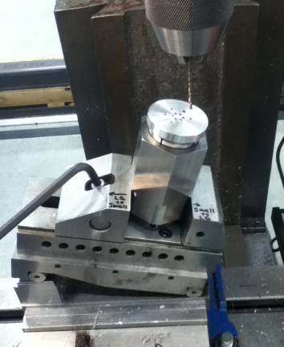

1. Loosen the vise and index the part for the next hole. Align the collet holder with the edge of the vise and tighten vise jaws.
2. Repeat steps 6 and 7 until all holes are drilled.

**Installing the Gas Director into the Injector housing:**

1. An interference fit of ( 0.0005” to 0.002” ) is incorporated into the design to help seal and retain the Gas Director in the Injector housing. In addition to this, a small amount of high temperature silicone is used to prevent gas from leaking through the screw holes used to fasten the Gas Director to the Injector housing.

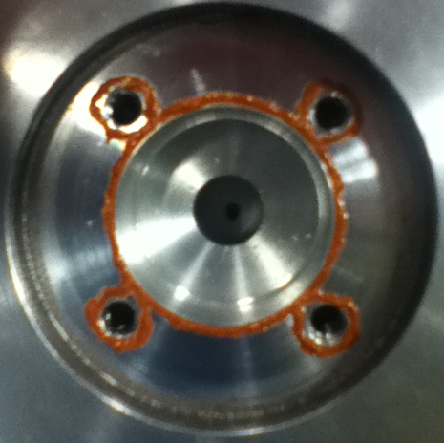

1. The pocket for the Gas Director is counter-bored -0.155” to help with alignment. Only the last 0.100” of the pocket comes in contact with the side of the Gas Director to make the seal.
2. A trace amount of anti-seize should be applied all the way around the wall of the pocket that will contact the Gas Director and to the radius area of the Gas Director that contacts the pocket first to prevent galling while the part is seated.
3. Align the pip mark on the Gas Director with the corresponding mark on the Injector surface. Align the screw holes and place the Gas Director into the housing. It should stand about 0.100” above the surface evenly all around.
4. Apply a very light amount of anti-seize to the screw threads and under the head of each screw. Install all four screws so that the head is about half way into the counter sink area provided in the Gas Director. This will rotate the part so each of the screw heads are properly positioned.
5. Moving in a clockwise direction gently turn the screws until they just touch the Gas Director.

1. Verify that the Gas Director stands **evenly** about 0.100” above the surface.

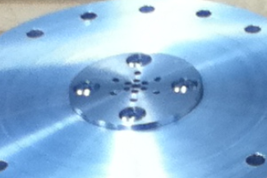 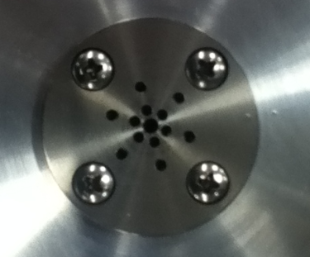

1. To seat the Gas Director evenly make sure to treat each of the four screws the same way by turning the screws a little bit at a time, moving in a clockwise direction. MAKE SURE the part is being pulled down evenly as the process continues. At the end, the part should be just below the surface by about 0.003 to 0.005 inches.

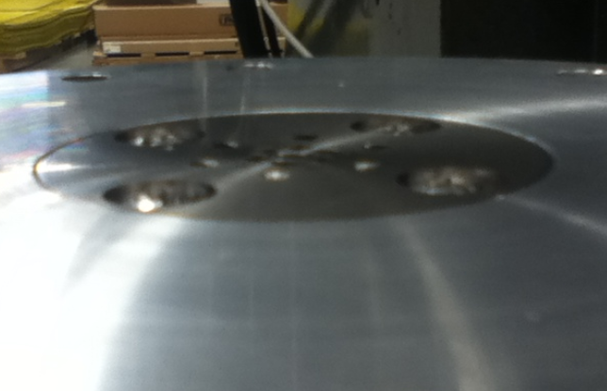

1. A holding fixture and removal tool have been provided in case the Gas Director needs replacing.

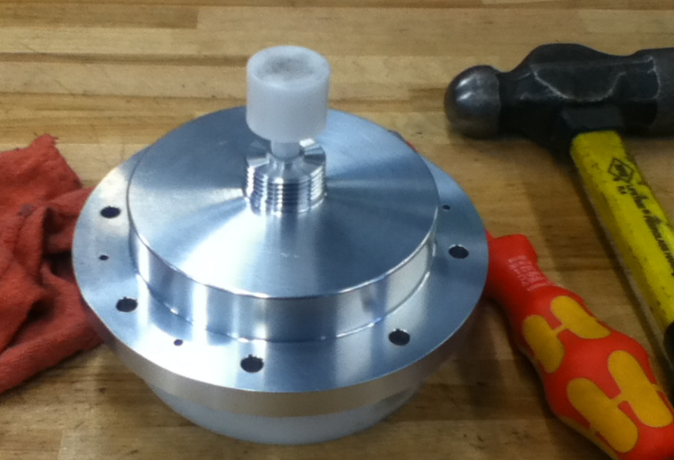

1. To remove the Gas Director, loosen all four screws about 1-1/2 turns then use the holding fixture and arbor to drive the Gas Director until it meets the screws. Loosen the screws about 1-1/2 turns again then with LESS FORCE, continue the process to move the part out of the pocket. REMEMBER the part is ONLY held by 0.100” of its thickness so it will move freely after that. Don’t drive against the screws and damage the housing.